Xenon Stack (2nd round process)

**Project Name:** My website name is:”CodeKida” BY this website our user can easily learn different programming language. But I mentioned only C language because of lack of time.

**Home page:**

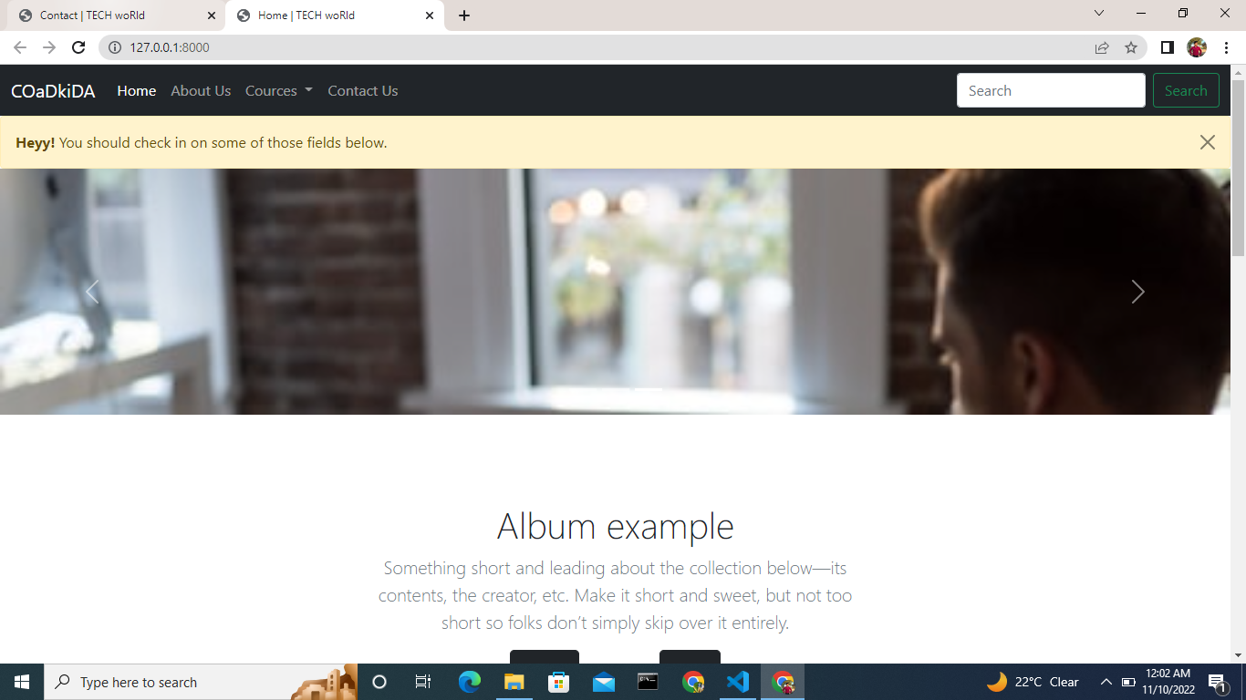

**About us page:**

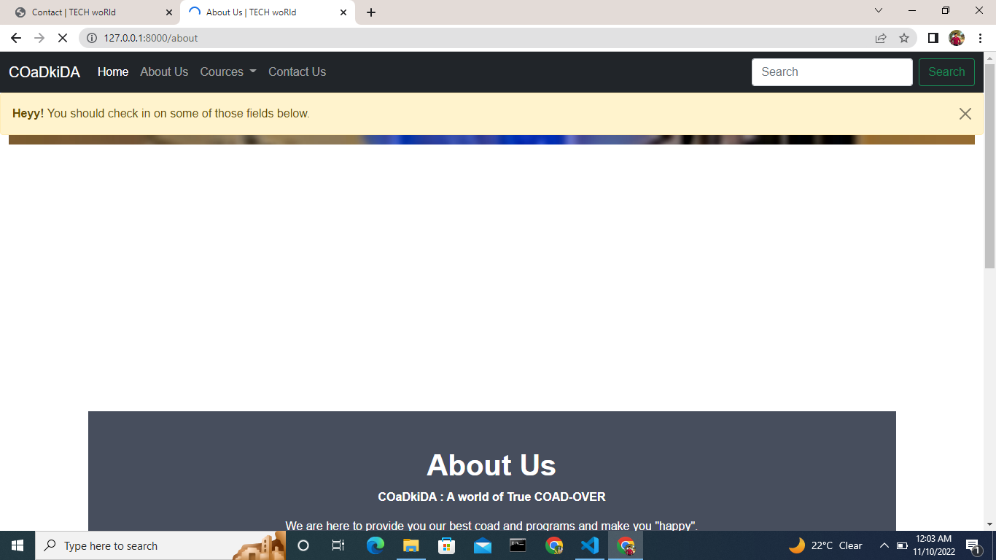

**Cources page(only c tutorial page):**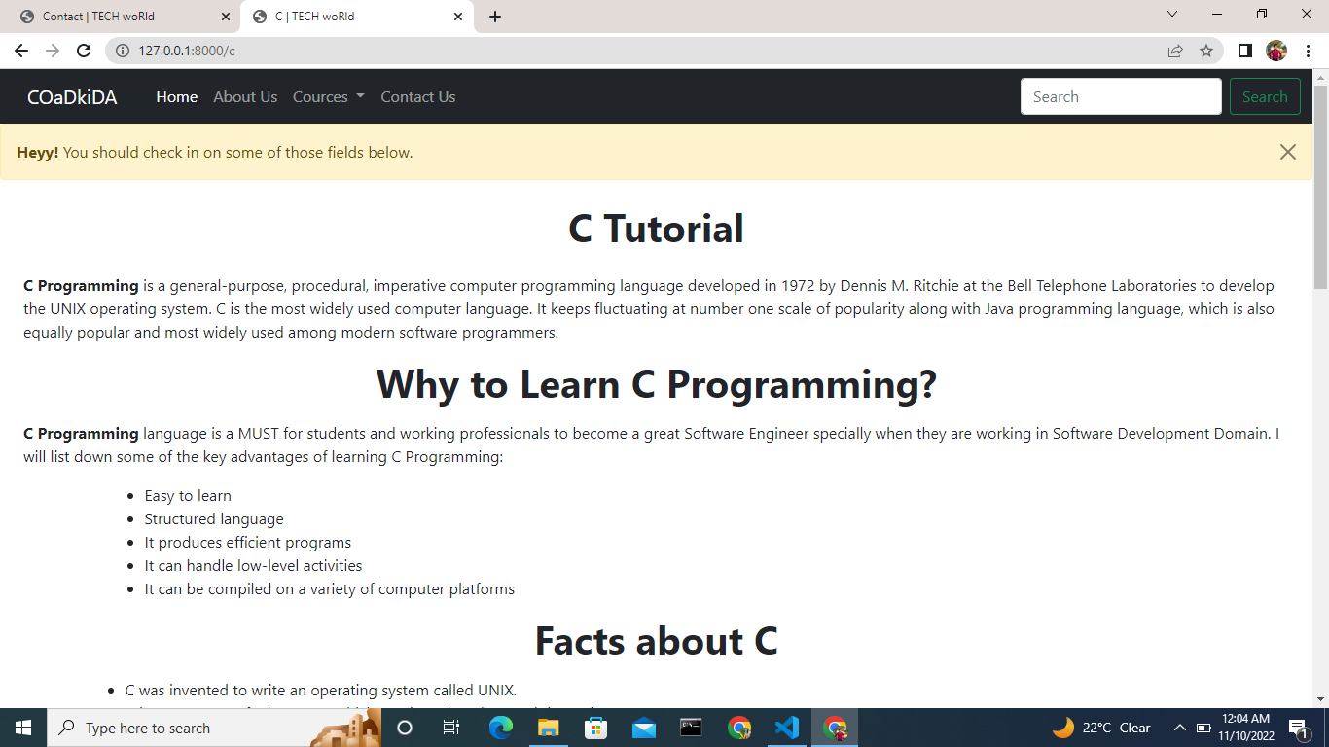

**Contact us page:**

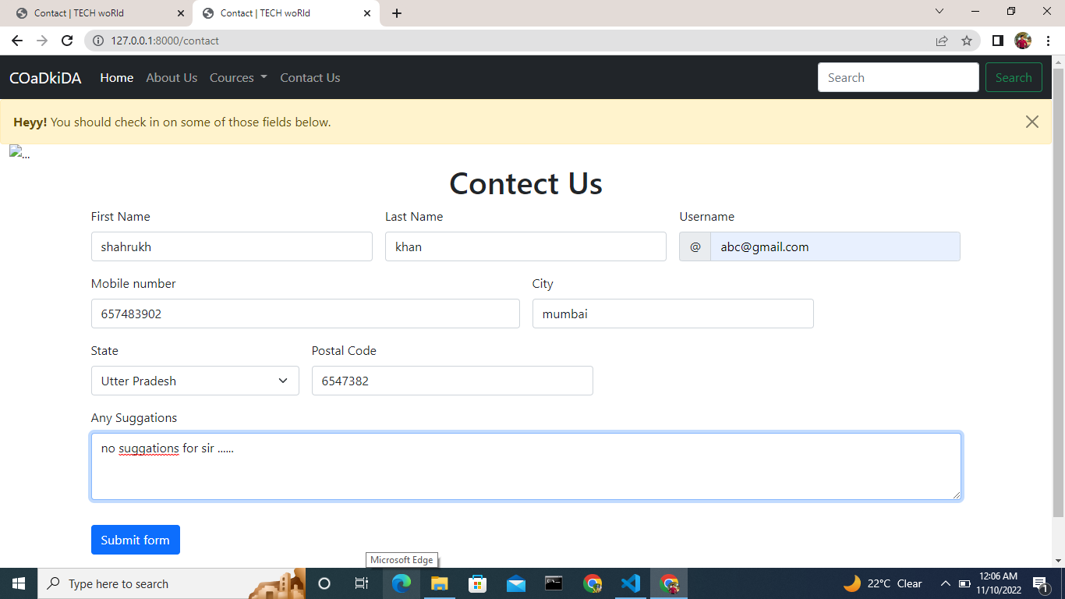

**Now Administrator page:**

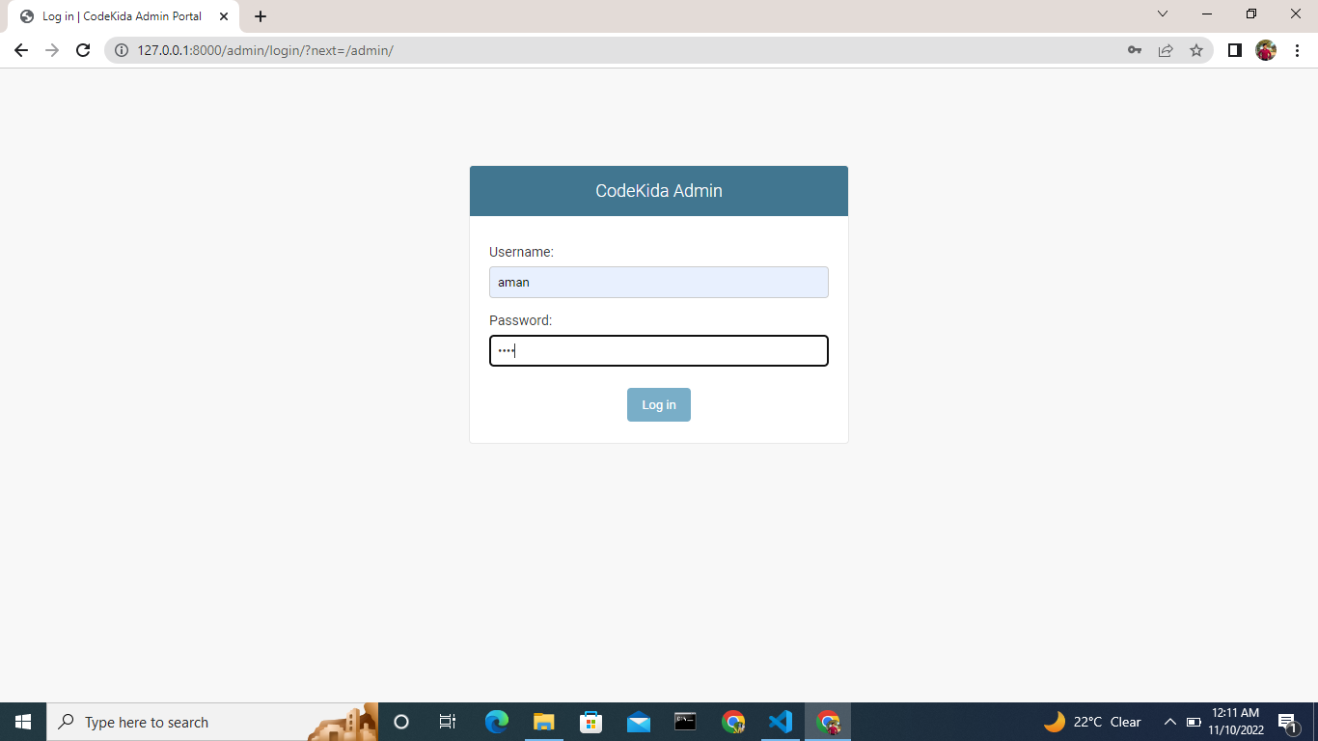

**Here password and username is “aman “ and “aman” .**

**Now Database:**

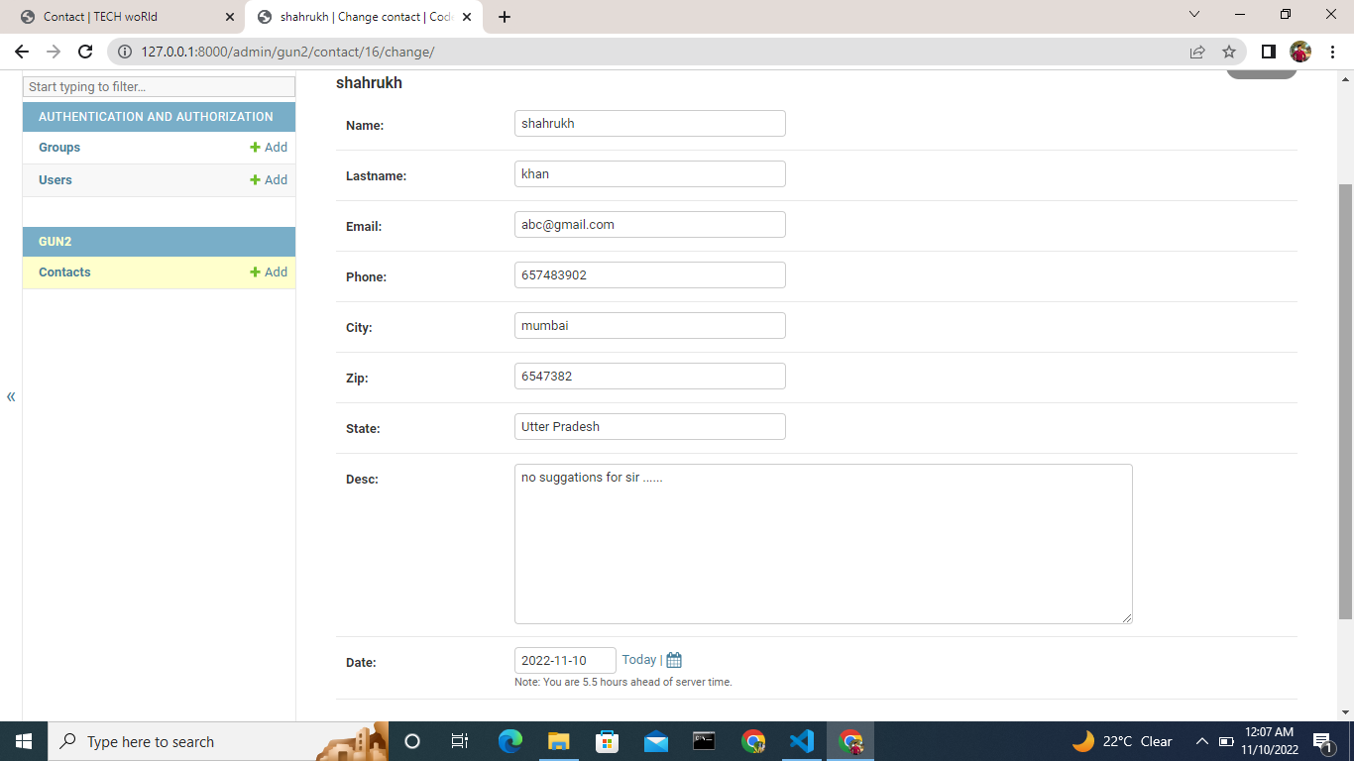

**Admin can easily log out using Logout option:**

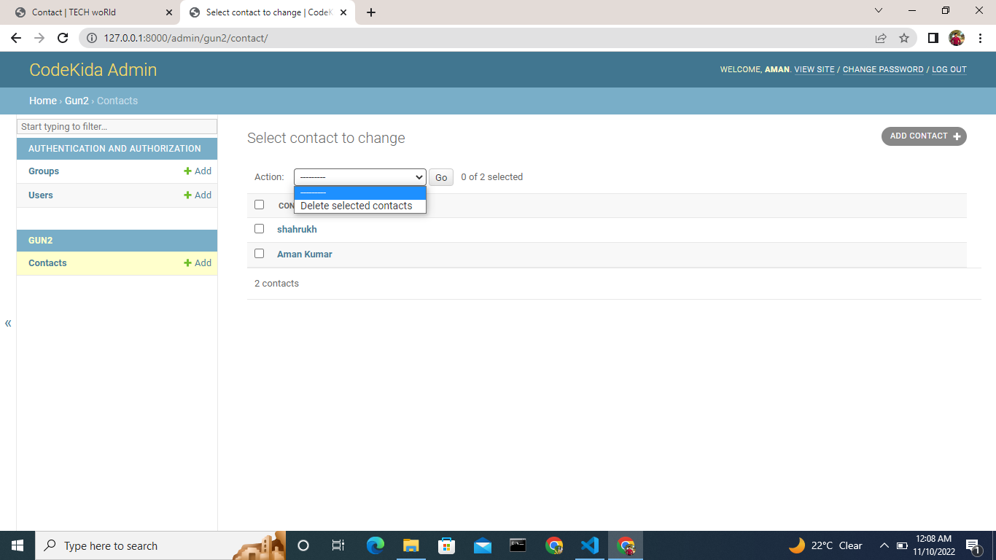

**You can see logout link at the corner.**